Day 1

First:

#include<stdio.h>

#include<ctype.h>

void FIRST(char);

int count,n=0;

char prodn[10][10],first[10];

main()

{

int i,choice;

char c,ch;

printf("How many productions:");

scanf("%d",&count);

printf("Enter %d productions epsilon= $ :\n\n",count);

for(i=0;i<count;i++)

scanf("%s%c",prodn[i],&ch);

do

{

n=0;

printf("Element :");

scanf("%c",&c);

FIRST(c);

printf("\n FIRST(%c)= { ",c);

for(i=0;i<n;i++)

printf("%c ",first[i]);

printf("}\n");

printf("press 1 to continue : ");

scanf("%d%c",&choice,&ch);

}

while(choice==1);

}

void FIRST(char c)

{

int j;

if(!(isupper(c)))

first[n++]=c;

for(j=0;j<count;j++)

{

if(prodn[j][0]==c)

{

if(prodn[j][2]=='$')

first[n++]='$';

else if(islower(prodn[j][2]))

first[n++]=prodn[j][2];

else

FIRST(prodn[j][2]);

}

}

}

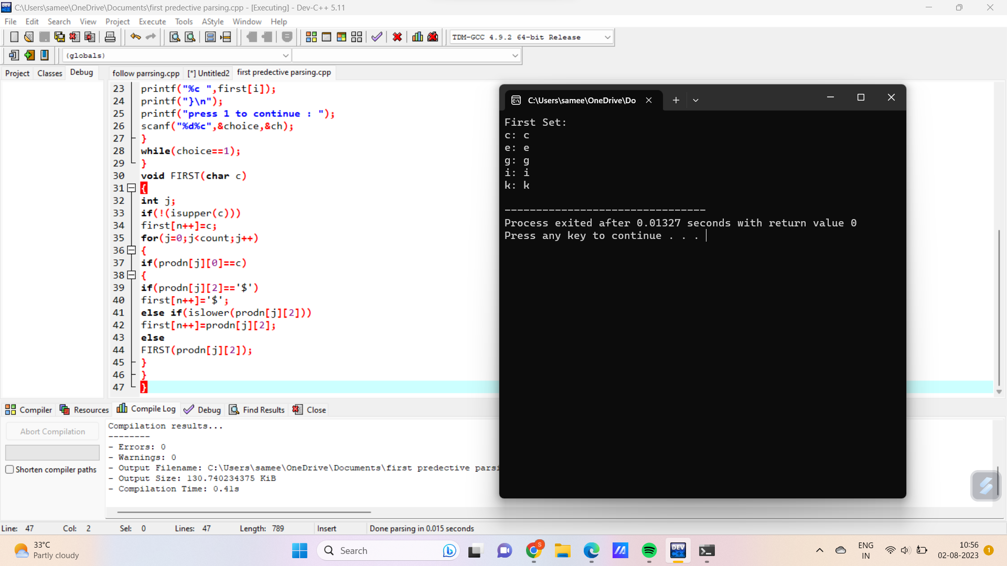

Follow:

#include<stdio.h>

#include<string.h>

int n,m=0,p,i=0,j=0;

char a[10][10],f[10];

void follow(char c);

void first(char c);

int main()

{

int i,choice;

char c,ch;

printf("Enter the no.of productions:");

scanf("%d",&n);

printf("Enter the productions(epsilon=@):\n");

for(i=0;i<n;i++)

scanf("%s%c",a[i],&ch);

do

{

m=0;

printf("Enter the element whose FOLLOW is to be found:");

scanf("%c",&c);

follow(c);

printf("FOLLOW(%c) = { ",c);

for(i=0;i<m;i++)

printf("%c ",f[i]);

printf(" }\n");

printf("Do you want to continue(0/1)?");

scanf("%d%c",&choice,&ch);

}

while(choice==1);

}

void follow(char c)

{

if(a[0][0]==c)f[m++]='e';

for(i=0;i<n;i++)

{

for(j=2;j<strlen(a[i]);j++)

{

if(a[i][j]==c)

{

if(a[i][j+1]!='\0')first(a[i][j+1]);

if(a[i][j+1]=='\0'&&c!=a[i][0])

follow(a[i][0]);

}

}

}

}

void first(char c)

{

int k;

if(!(isupper(c)))f[m++]=c;

for(k=0;k<n;k++)

{

if(a[k][0]==c)

{

if(a[k][2]=='@')

follow(a[i][0]);

else if(islower(a[k][2]))

f[m++]=a[k][2];

else

first(a[k][2]);

}

}}